|  |
| --- |
| **SOUTHERN CROSS UNIVERSITY** |

**ASSIGNMENT COVER SHEET**

For use with online submission of assignments

Please complete all of the following details and then make this sheet the **first page of each file of your assignment – do not send it as a separate document.**

Your assignments must be submitted as either **Word documents, text documents with .rtf extension or as .pdf documents**. If you wish tosubmit in any other file format please discuss this with your lecturer well before theassignment submission date.

|  |  |
| --- | --- |
| Student Name: | **Jennifer Doherty** |
| Student ID No.: | **22223407** |
| Unit Name: | **Database Systems I** |
| Unit Code: | **CSC00228** |
| Tutor’s name: | **Kathryn Gibney** |
| Assignment No.: | **3B** |
| Assignment Title: | **Database Prototype** |
| Due date: | **29 May 2016** |
| Date submitted: | **28 May 2016** |

Declaration:

*I have read and understand the Rules Relating to Awards (*[*Rule 3 Section 18 – Academic Misconduct Including Plagiarism*](http://policies.scu.edu.au/view.current.php?id=00140#s18)*) as contained in the SCU Policy Library. I understand the penalties that apply for plagiarism and agree to be bound by these rules. The work I am submitting electronically is entirely my own work.*

|  |  |
| --- | --- |
| Signed:  (please type your name) | Jennifer Doherty |
| Date: | 28 May 2016 |

ASSIGNMENT Three Part B:

Database Prototype

By Jennifer Doherty

Table of Contents

Entity Relationship Diagram 4

Analysis 5

Client Business Rules 5

Assumptions Made 5

Testing Queries 6

i. Club membership list 6

ii. Club members count 7

iii. Owing memberships 8

iv. Regatta information 9

v. Race information 10

vi. Winner list 11

vii. Particular member race list 12

viii. Boats used in regattas 13

ix. Qualification list 14

x. Refresher training list 15

# Entity Relationship Diagram

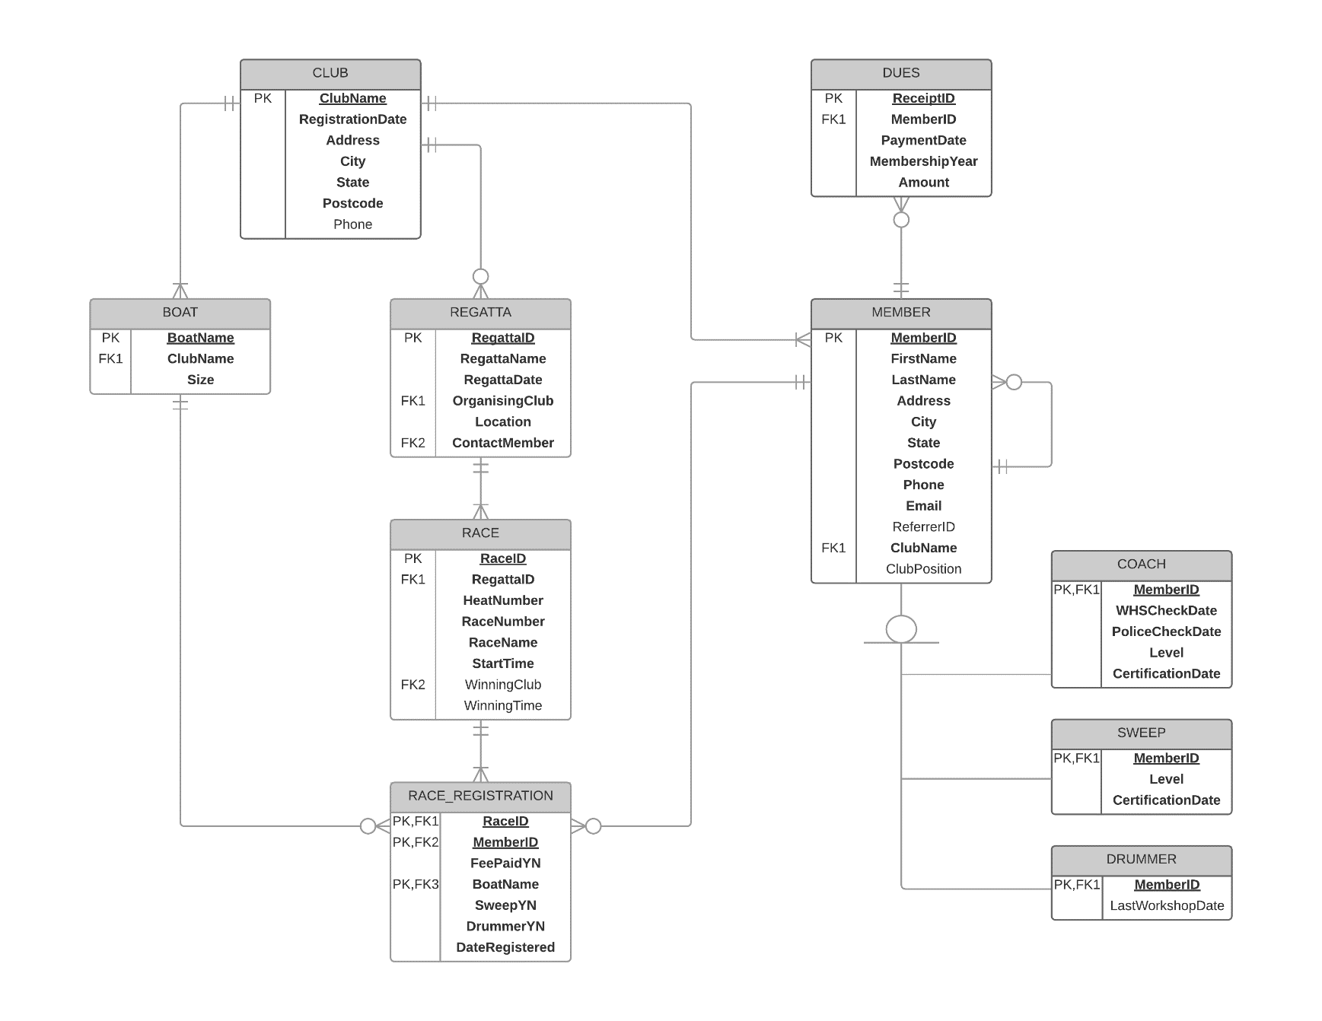

# Analysis

## Client Business Rules

* A new club must have at least four prospective members, who fill the required club positions of President, Vice-President, Secretary, and Treasurer.
* There is a maximum of four boats in each race.
* Only boats of the same size can compete in the same race.
* The certification levels for Coaches and Sweeps range from 1 to 5.
* Annual membership dues may be paid in instalments.

## Assumptions Made

* New club members may be referred by existing club members, but this is not required.
* Attending a drumming workshop is optional – drummers are not required to have any qualification.
* Boat names are unique within the Association.
* Club names are unique within the Association.
* More than one member may indicate on their race registration form that they wish to be the drummer for a particular boat in a particular race, and the club decides on the day which drummer they will use for that race.
* If a member is not qualified as a sweep, they may still register for a race as a sweep and either obtain their qualification at the regatta on the day or race without it.
* The “Date” field on the Race Registration form is the date the member registered for the listed races, and may be different to the Regatta date.

# Testing Queries

Please note: due to the large amount of data returned for some queries, if there is more data than will fit on one screen then the first screen only is displayed for each query result.

## Club membership list

SELECT `Full Name`, Email, Phone, `Club Position`

FROM Member_Contact_View

WHERE `Club` = "Auris Dragon Boat Club";

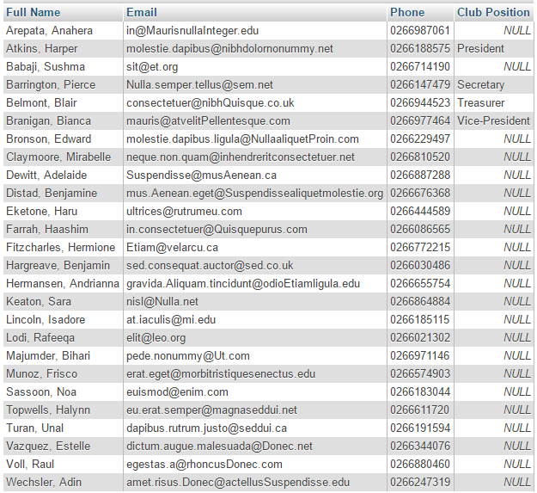

## Club members count

SELECT MEMBER.ClubName As `Club name`, COUNT(*) As `Club members count`

FROM MEMBER

GROUP BY MEMBER.ClubName

ORDER BY `Club members count`,ClubName;

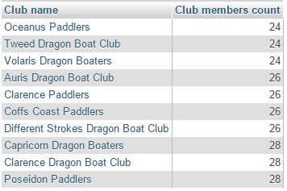

## Owing memberships

SELECT Club, `Full Name`, Email, Phone, `Year`, CONCAT("$",CAST(`Total Paid` AS char(7))) AS `Total Paid`

FROM Annual_Dues_Paid_View

WHERE `Total Paid` < 100

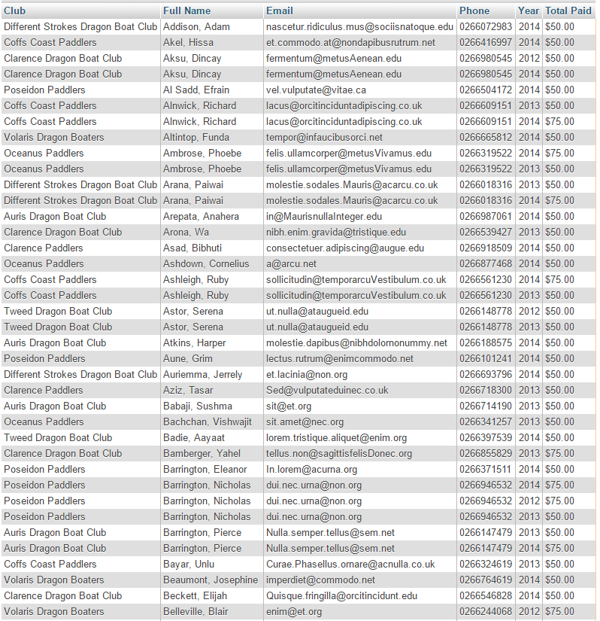

## Regatta information

SELECT RegattaName AS Regatta, DATE_FORMAT(RegattaDate,'%d/%m/%Y') AS `Date`, Location, OrganisingClub AS `Organising Club`, `Full Name`, Email, Phone

FROM REGATTA LEFT JOIN Member_Contact_View

ON REGATTA.ContactMember = Member_Contact_View.MemberID

ORDER BY RegattaDate;

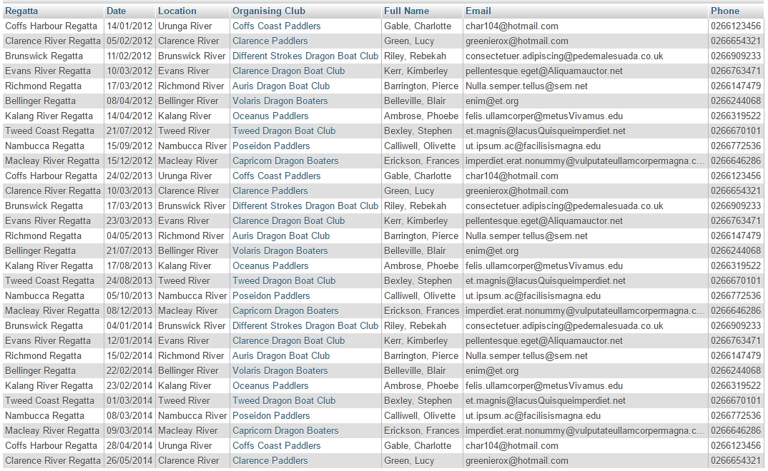

## Race information

SELECT RegattaName AS Regatta, HeatNumber AS Heat, RaceName AS `Race Name`, StartTime AS `Starting Time`

FROM RACE JOIN REGATTA

ON RACE.RegattaID = REGATTA.RegattaID

WHERE RACE.RegattaID = 22

ORDER BY Heat, RaceNumber;

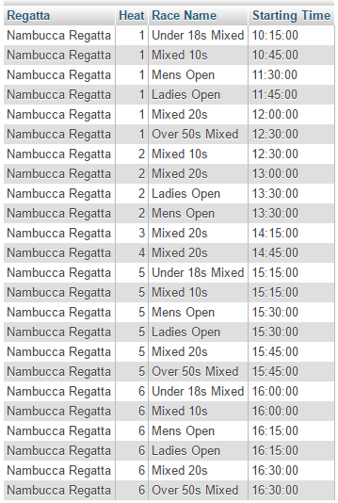

## Winner list

SELECT CONCAT(RegattaName, " ", DATE_FORMAT(RegattaDate, '%Y')) AS Regatta, HeatNumber AS Heat, RaceNumber AS Race, RaceName AS `Race Name`, WinningClub AS `Winning Club`, WinningTime AS `Winning Time`

FROM RACE JOIN REGATTA

ON RACE.RegattaID = REGATTA.RegattaID

GROUP BY REGATTA.RegattaID, Heat, Race

ORDER BY Regatta, Heat, `RaceNumber`;

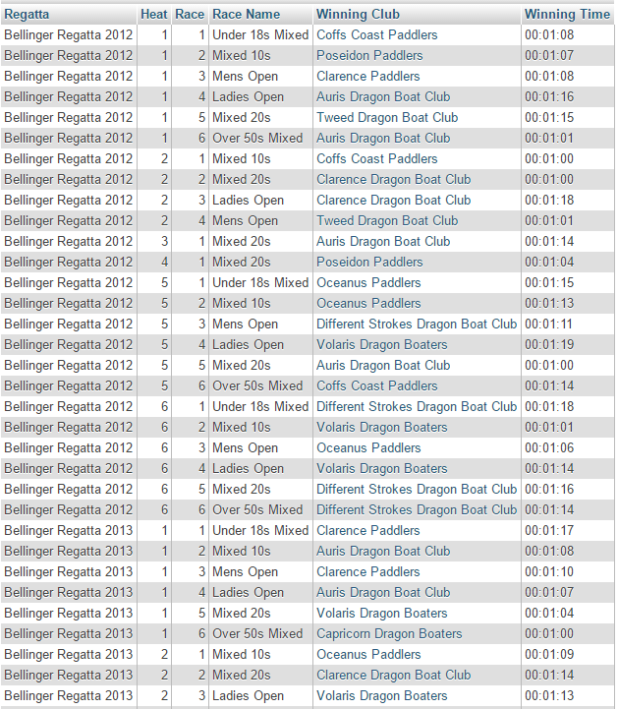

## Particular member race list

SELECT `Full Name`, Regatta, DATE_FORMAT(`Date`,'%d/%m/%Y') AS `Regatta Date`, Club, Heat, Race, `Race Name`, `Start Time`, Boat, Sweep, Drummer, `Fee Paid`

FROM `Regatta_Registration_View`

WHERE `Full Name` = "Morse, Lucas" AND DATE_FORMAT(`Date`, '%Y') = 2014

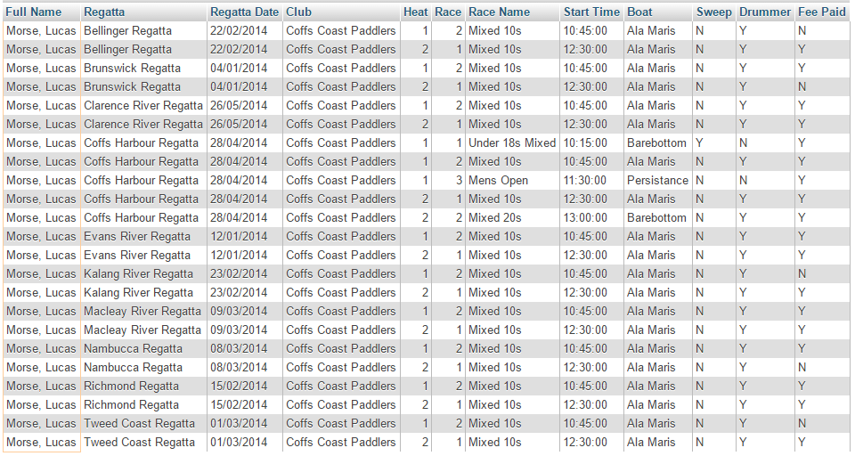

## Boats used in regattas

SELECT ClubName AS Club, BOAT.BoatName AS Boat, COUNT(*) As `Race Count`

FROM BOAT JOIN RACE_REGISTRATION

ON BOAT.BoatName = RACE_REGISTRATION.BoatName

JOIN RACE

ON RACE_REGISTRATION.RaceID = RACE.RaceID

JOIN REGATTA

ON RACE.RegattaID = REGATTA.RegattaID

WHERE DATE_FORMAT(RegattaDate, '%Y') = 2014

GROUP BY Boat

ORDER BY Club, Boat;

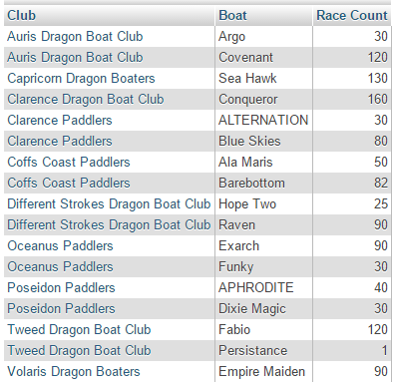

## Qualification list

SELECT Club, `Last Name`, `First Name`, Phone, `Coach Level`, `Coach Certification Date`, `Sweep Level`, `Sweep Certification Date`

FROM Member_Qualification_View

WHERE `Coach Level` IS NOT NULL OR `Sweep Level` IS NOT NULL

GROUP BY MemberID

ORDER BY Club, `Last Name`, `First Name`;

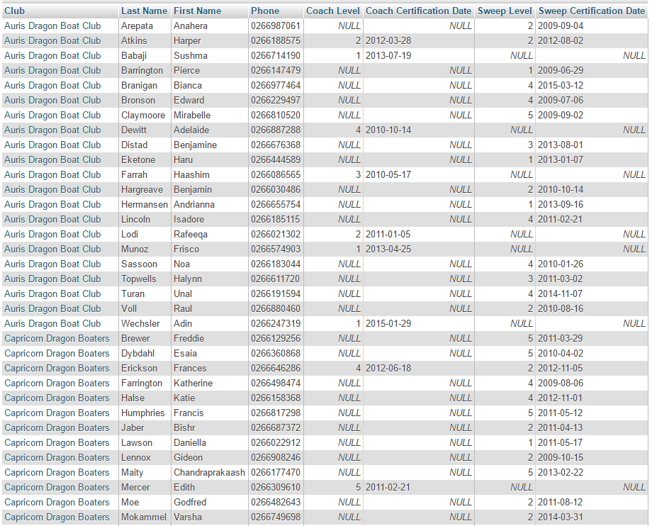

## Refresher training list

SELECT Club, CONCAT(`Last Name`, ", ", `First Name`) AS `Full Name`, Email, Phone, DATE_FORMAT(`Coach Certification Date`,'%d/%m/%Y') AS `Date`

FROM Coach_View

WHERE DATEDIFF(NOW(), `Coach Certification Date`) > 1095

ORDER BY `Coach Certification Date`;

